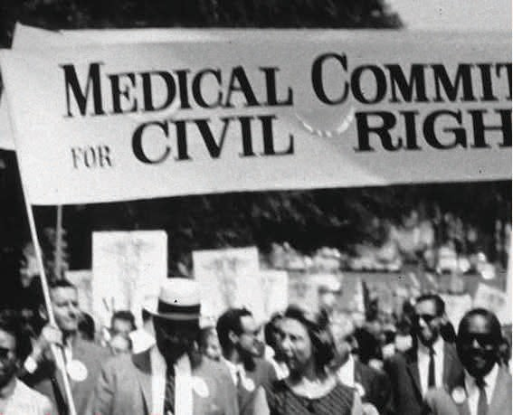

Film Screening
TRANSFORMING AMERICA'S SEGREGATED HOSPITALS
THE POWER TO HEAL
POWER TO HEAL is an hour-long public television documentary that tells a poignant chapter in the historic struggle to secure equal and adequate access to healthcare for all Americans. Central to the story is the tale of how a new national program, Medicare, was used to mount a dramatic, coordinated effort that desegregated thousands of hospitals across the country in a matter of months.

SAVE THE DATE
Tuesday, May 1, 2018 | 5:30 - 8:30 pm
Tosteson Medical Education Center (TMEC) Amphitheater
Harvard Medical School, 260 Longwood Avenue, Boston

•  Film Screening
PROGRAM •  Panel Discussion
•  Reception

RSVP by Monday, April 23rd: www.surveymonkey.com/r/power-to-healfilmscreening
Questions? Call: 617-432-2313 or Email: ying_wang@hms.harvard.edu

Hosted by :
Harvard Medical School Office for Diversity Inclusion and Community Partnership

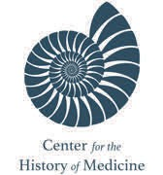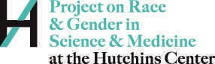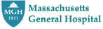Co-sponsors:

