  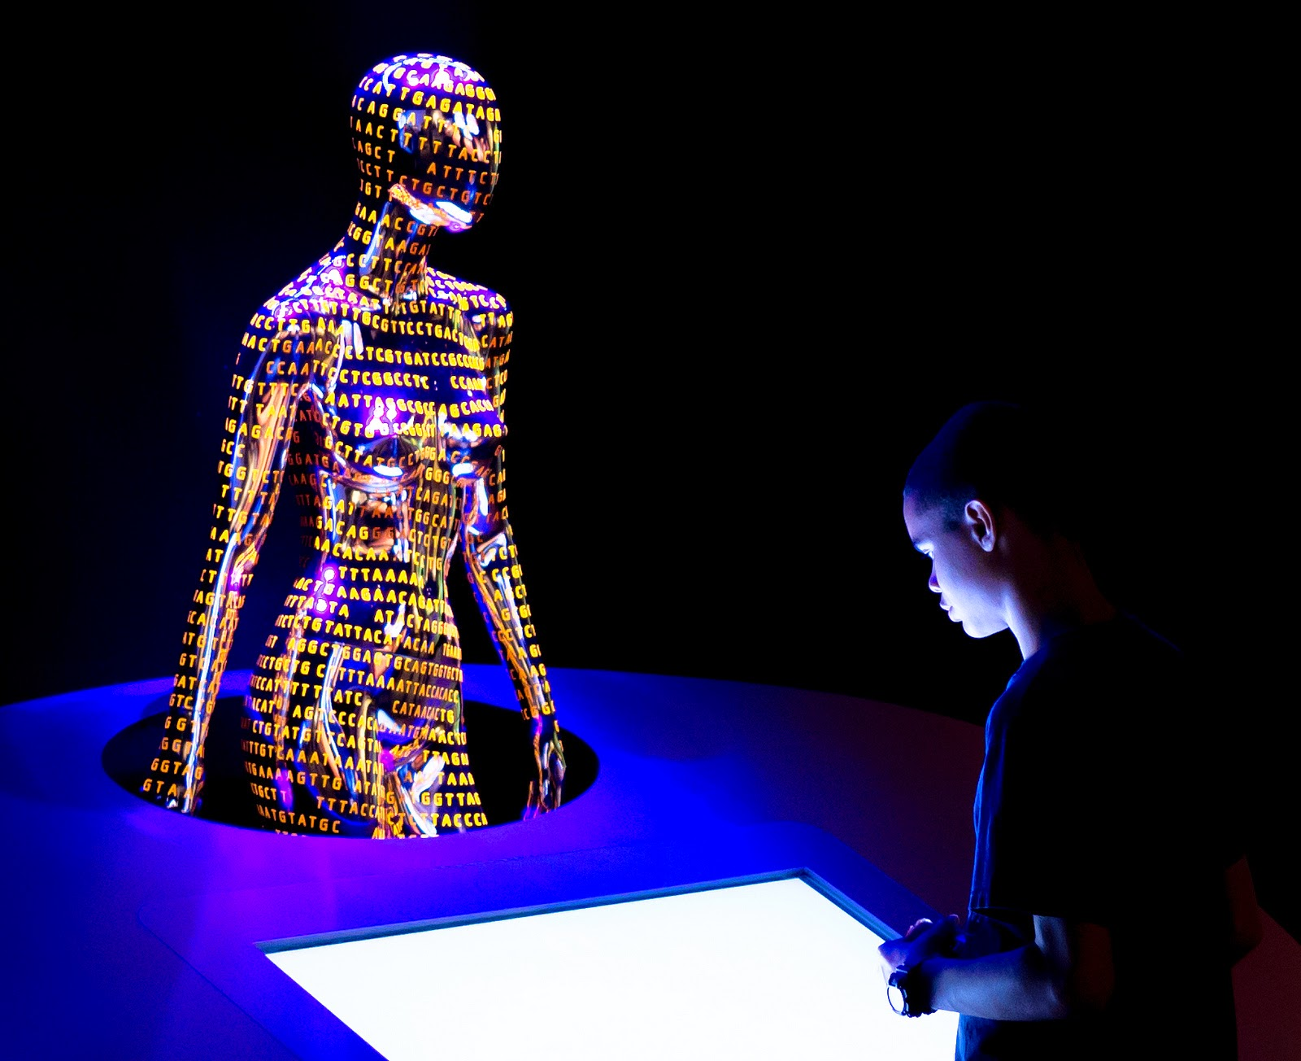
    - hist 147
  the changing concept of race in america: from jefferson to genomics
  This course explores changing concepts of race in American science and medicine, and examines the historical meanings and uses of these concepts in U.S. society from the 18th century to the present. The course asks the following questions: How have diverse scientific and medical disciplines historically defined, measured, and produced knowledge about race? How have scientific and medical concepts of race historically interrelated with key political, economic, and social institutions? How do current 21st century genomic concepts of race fit into this larger history of race and science?
  History of Science 147
  The Changing Concept of Race in America:
  From Jefferson to Genomics
  Prof. evelynn
  hamMONDS
  COURSE NUMBER: HIST 147 TIME: THURSDAYS 2-4PM
  LOCATION: SCIENCE CENTER 469

